***THEORY: -***

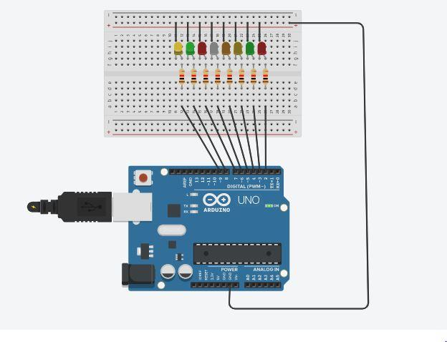

***CONCEPT USED:-*** ***The concept of the following experiment is state as,the seven led’s will blink one after another.***

* ***There should not be any time duration between the off of previous light and the on of the next consecutive light.***

***LEARNING AND OBSERVATION:-***

* ***First thing I observed is that our LED chaser is totally dependent on the code we write. We can alter the switching ON and switching OFF of LED by changing in our code.***
* ***Ground pin is always attached to the negative part of LED which is usually small in length.***
* ***Output pins are connected to positive terminal of the LED and positive terminal of a LED is usually a longer length.***
* ***We have 13 output pins and we are free to use anyone.***

***PROBLEMS AND TROUBLESHOOTING:-***

* ***First a biggest problem I faced is connection of wiring `in breadboard. One should be careful while adjusting pins in breadboard. Use only those pins which you have written in code for output.***
* ***I also wrote the code in such a manner that switching ON and OFF of LED’s become unsymmetrical. This was the another problem I faced. At that time, syntax of code was correct but LED’s were switching ON and OFF in unsymmetrical manner.***

***Precautions:-***

* ***The wiring/connections should be made proper.***
* ***Delay should be short to make a chaser.***
* ***Appropriate resistor should be used to minimize the flow of current so that it does not damage the LED.***
* ***One should be aware of the errors while running it to fix the problems.***

***Learning Outcomes:-***

* ***Fluent in making Series and Parallel connection in a Breadboard.***
* ***Various methods to identify the anode and cathode of an LED.***
* ***Programming commands in Arduino IDE.***
* ***Write program for chasing action of LED.***
* ***Loops in Arduino.***